# Vendor History

Tags are a useful feature in Sortly that allows for different items that fall under the same group to be easily organized and accessed. Creating different tags for different vendors allows the user to see which items fall under the same food distribution source.

This is because Sortly has an easy to access tag tab that shows all of the items that fall under each tag.

Creating Tag:

On the left side menu bar, there is a small tag icon. When you click on the icon, you are able to add new tags and view pre-existing ones as well.





Steps:

1. Create a tag with the name of a food vendor
2. Create new items and select a tag to place it under



Things to keep in mind:

* Each item can only belong to one tag so when creating an item that is distributed from multiple different vendors, you would have to change the name a bit
  + For example: bread from vendor A vs bread from vendor B

1. Create separate items named Bread - A and Bread - B
2. Add Bread - A under the vendor A tag and Bread - B under the vendor B tag

# Item History

Receiving History:

When receiving a completely new Item, you would have to manually create that item in the warehouse inventory folder. It that item exists, you can simply just update that quantity of that item.



The history will show all of the changes made to that item



If you want to view all of the received item history, you can view the warehouse inventory folder history.



Now you can see all of the items created and their dates of creation



Distribution history:

The steps for viewing distribution history are similar to viewing the receiving history. Instead, you would be just be viewing item history under the folder that keeps track of items going out of the warehouse.



On Hand Count:

The count of each item is displayed on the item view.

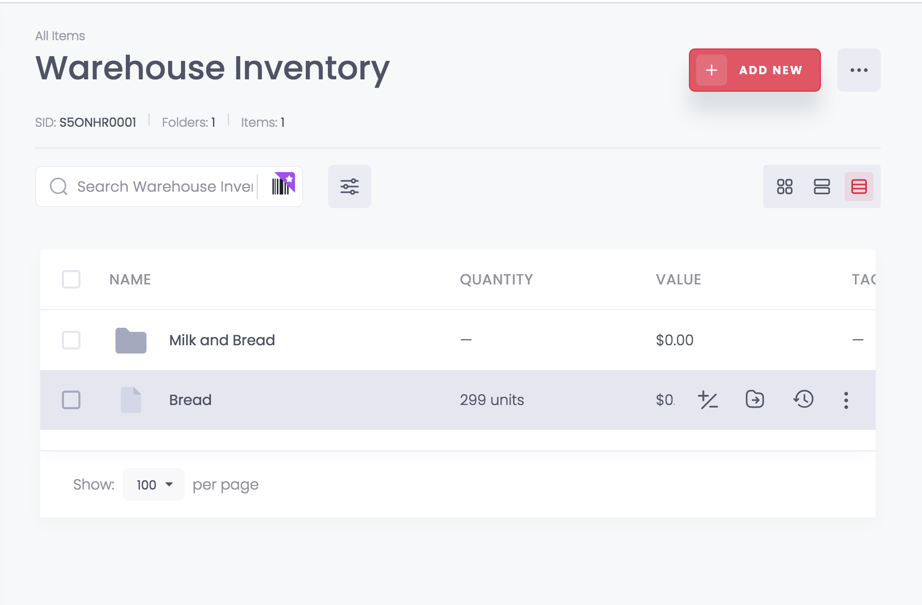

Item Description, Weight, Exp Date:

**Item description** can either be viewed when clicking into the item, or by clicking on the second view option on the top right corner of the screen.



When creating a new item, you can add the description of the item under the Notes section. This section can be edited anytime

**Item weight** is not a pre-existing field in the Sortly system. However, you can easily create a new field when editing item information.



This takes you to a separate custom fields page where you can view your existing custom fields as well as add a new one. When you click add new field, Sortly gives a variety of different inputs you can choose. In most cases, a small text box is enough.

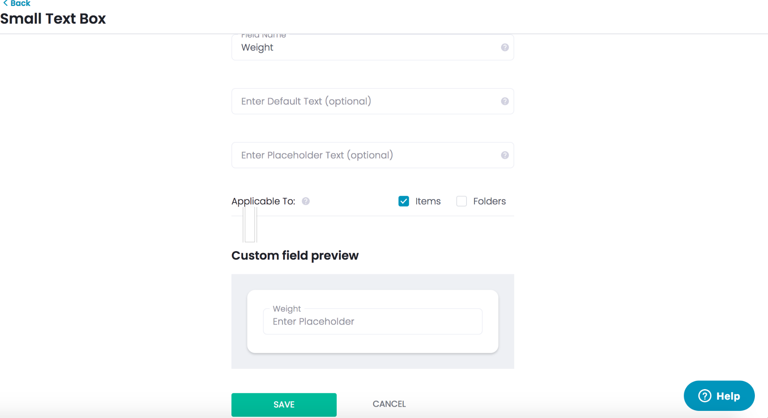

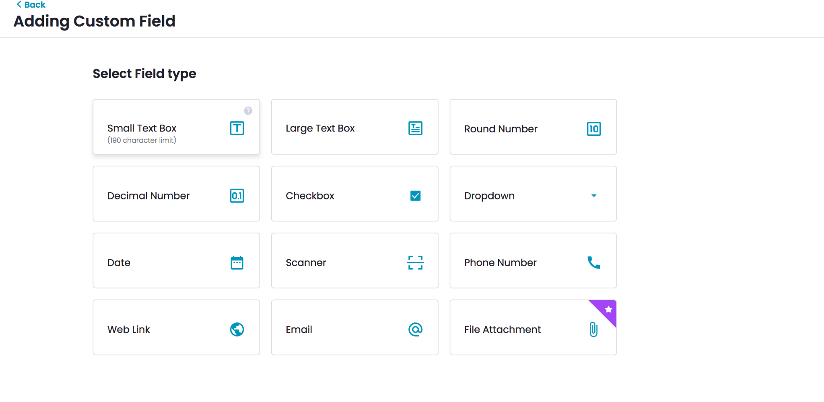

Once you save this field, you can now use this field on your items.

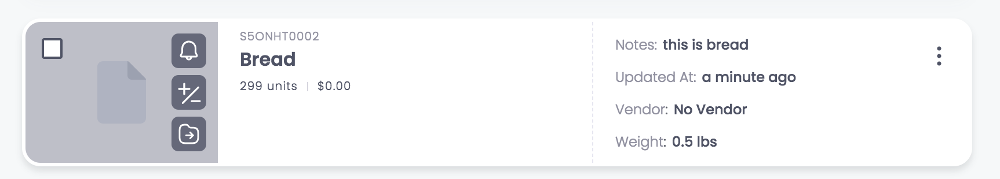

**Item expiration date** can also be added as a custom field

Box Assembly

Which items in an assembly

*Version 1: Tags*

One way to do this is to create a tag for an assembly and then assign that tag to the items that belong to that assembly.

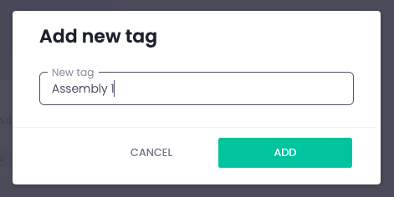

Once you create the assembly tag, you can assign the tag to the item.

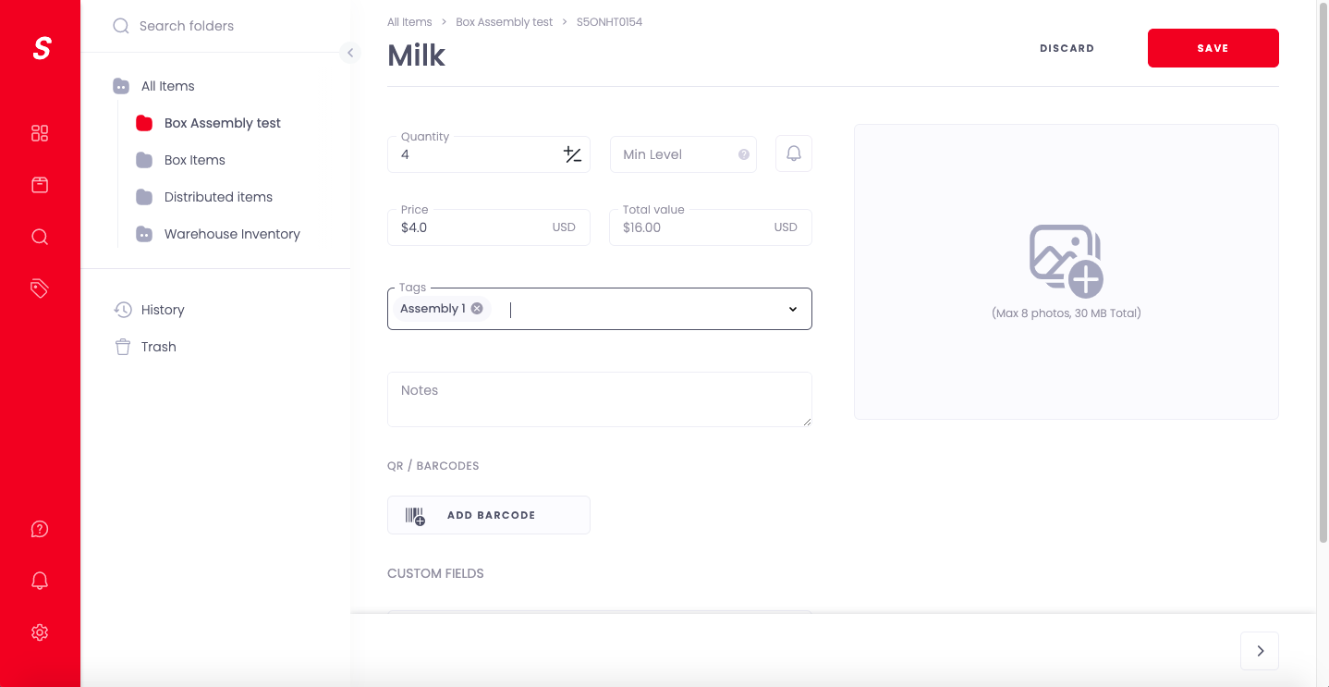

Then on the tag tab you can select the assembly you want, and it will show the items that belong to it.

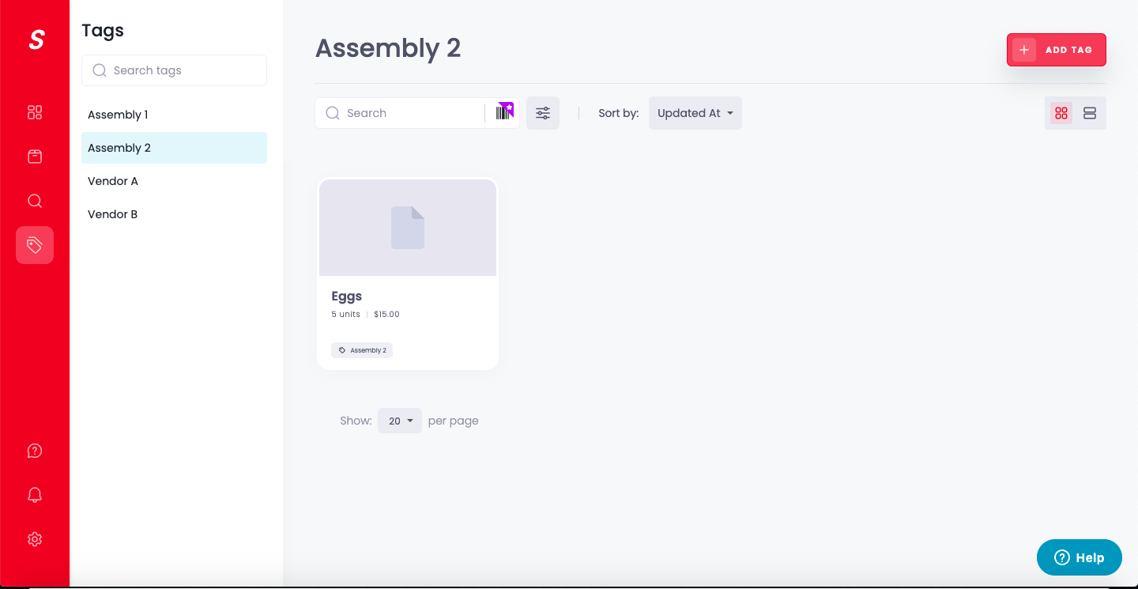

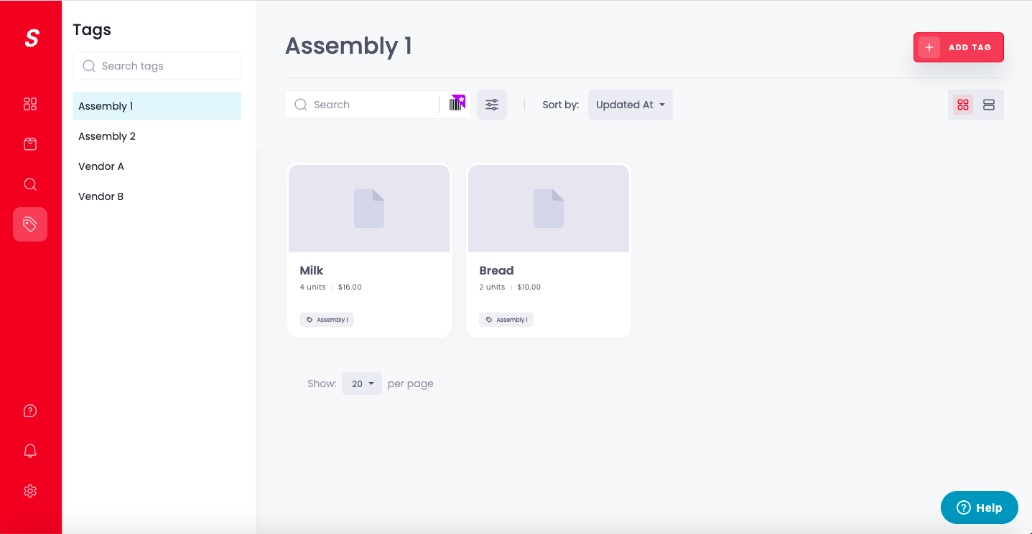

*Version 2: Using Custom Field*

Another way to create an assembly and assign items to it is through the custom field attribute of the item.

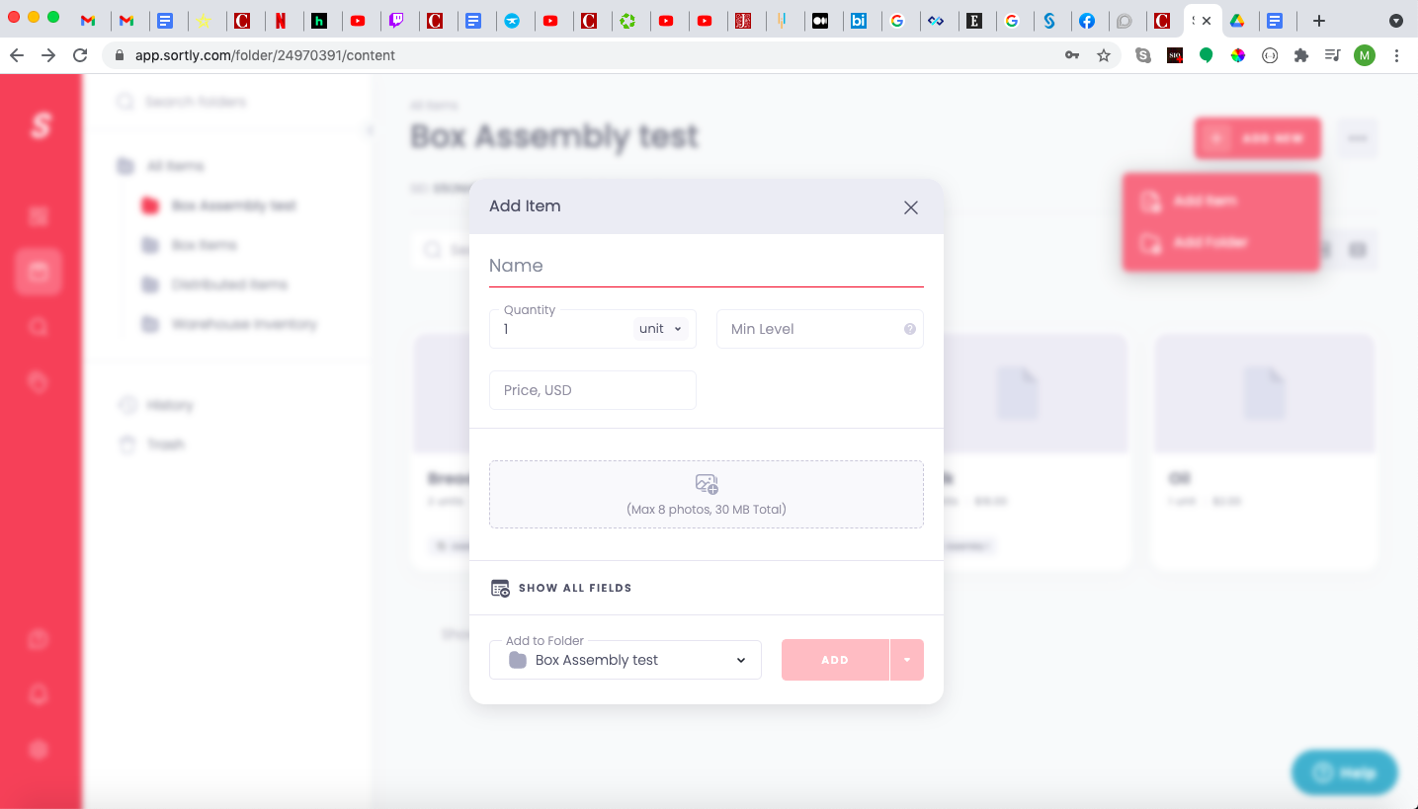

When you are creating an item, there is an option to “SHOW ALL FIELDS”. This links to a new creation page that allows you to assign more attributes to an item. In other words it is a more detailed creation page. 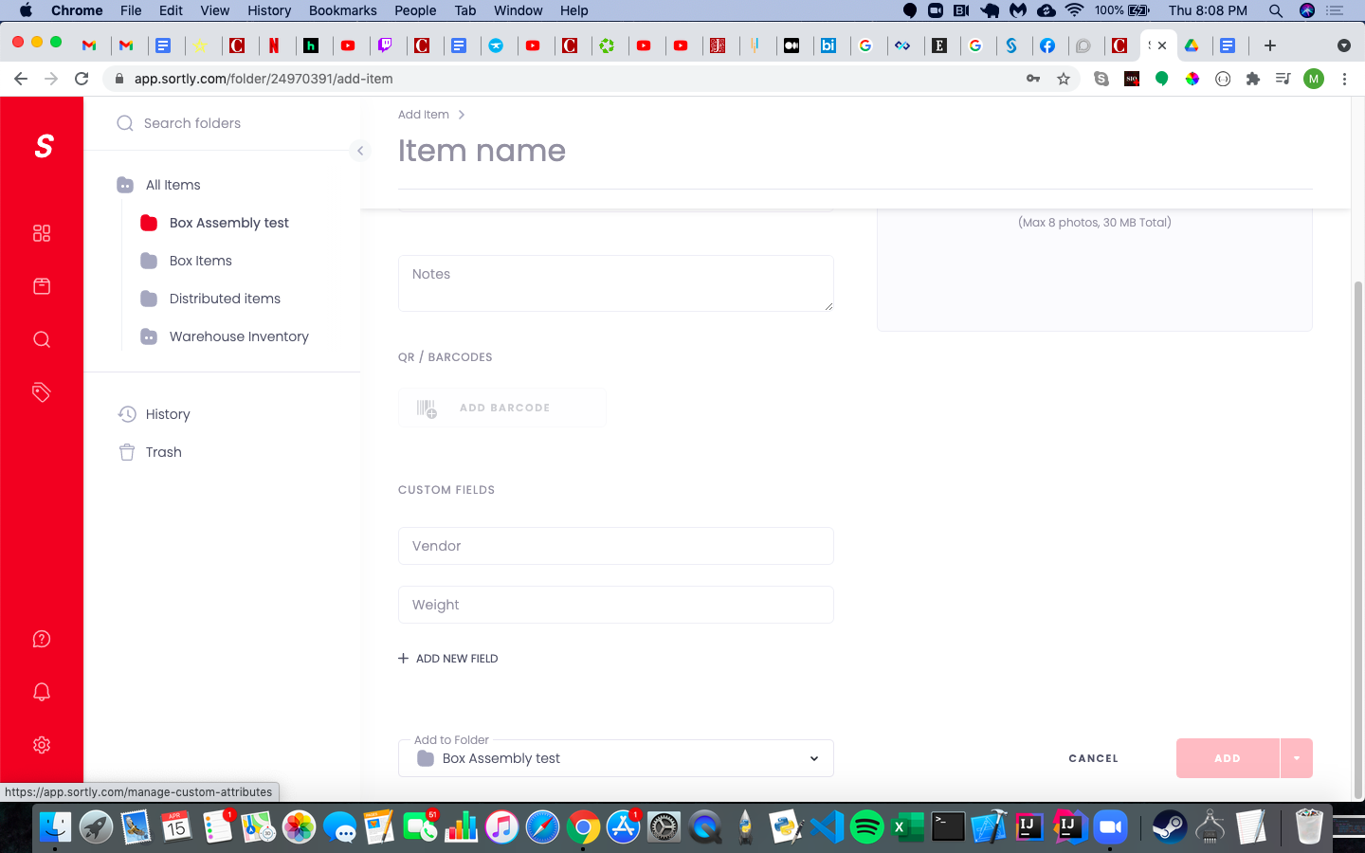

At the bottom of this creation page there should be a Custom fields section. This is where you can create a custom field for the assembly.

Once you create a custom field and are redirected back to the item creation page, the field will show up and you can populate it with whatever you like. 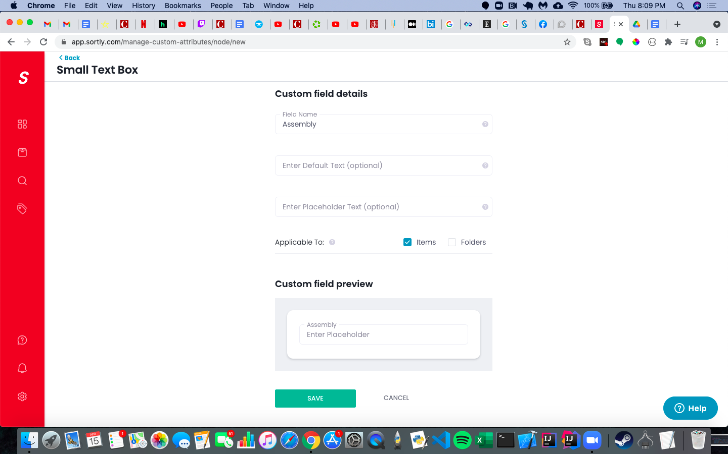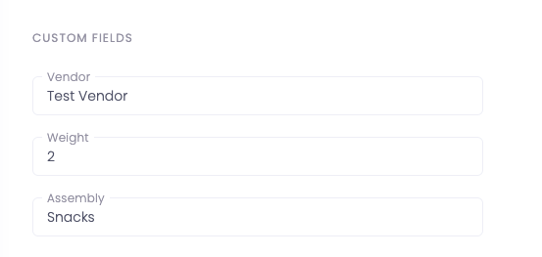

Now on the home page you can search for the item using an advanced search.

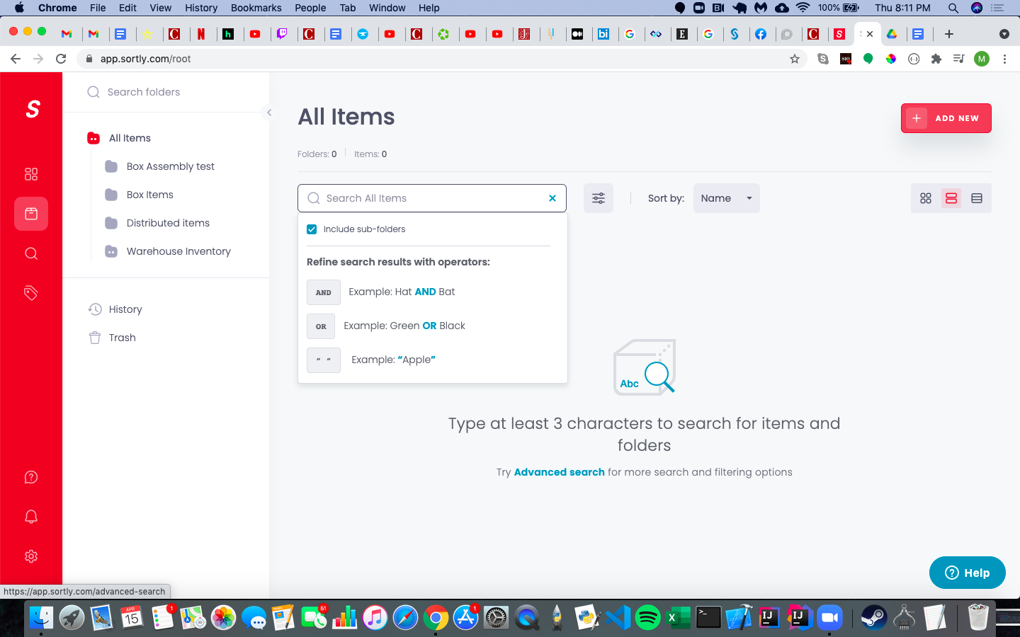

On the filters for the advanced search there should be a section for the new field you created, which has the different assembly names you assigned. 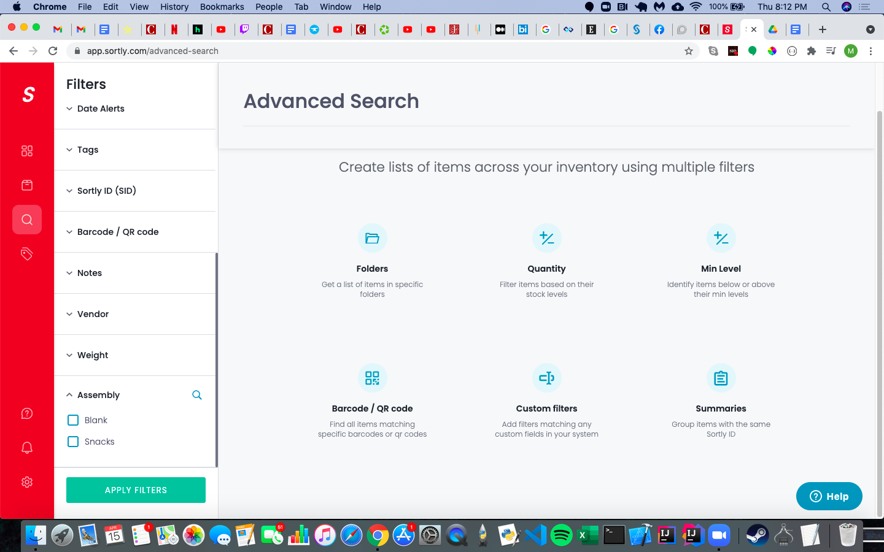

When applying the filter the item should show up.

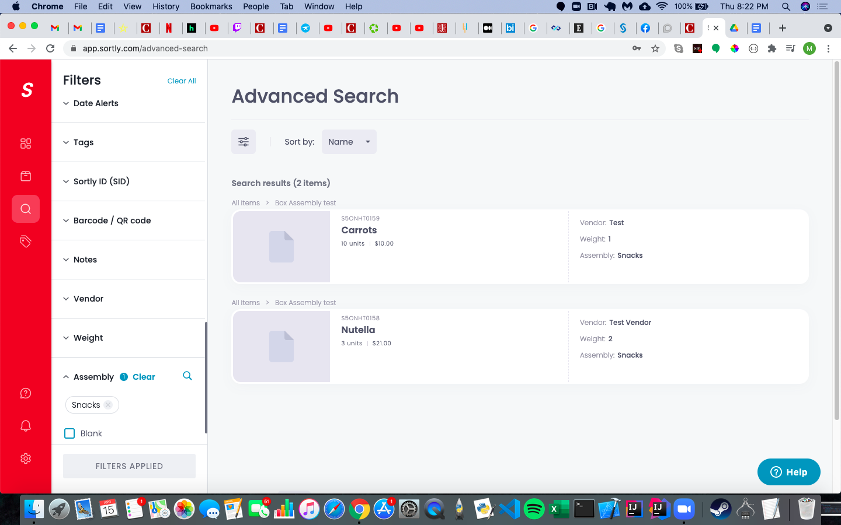

Customer History

Create a new folder for “distributed items” and move everything being distributed to a specific pantry into that folder - This can also help with distribution records.

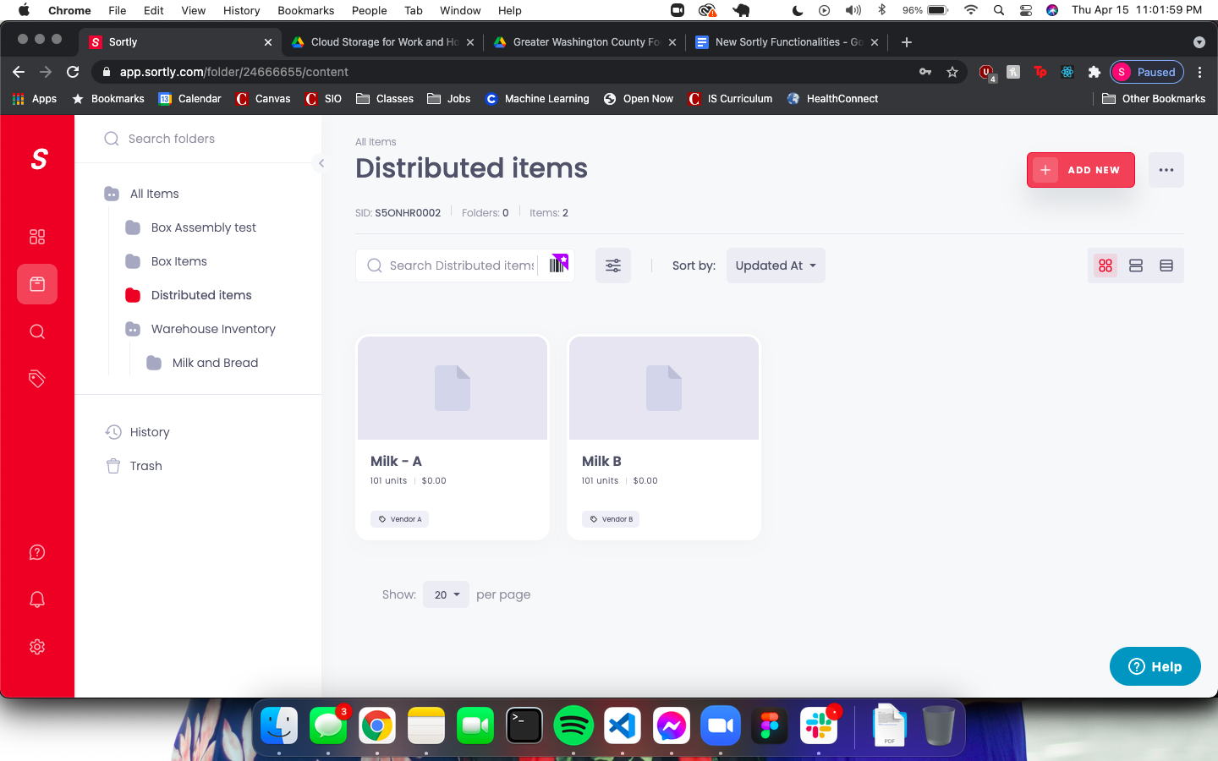

On the top right, click the 3 dots to the right of the “Add new” button



Press the “History” option from the menu



You can tag each addition to the folder with the specific pantry it was distributed to, and then filter history by tags and date range to get a specific range of distributions.

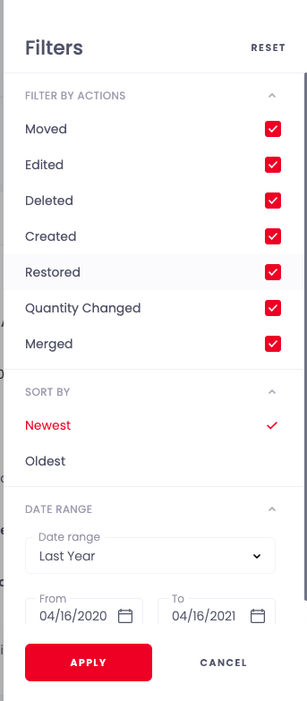

# Mobile Scanning

Download the Sortly Application from the app store and log in to your account on the home screen.

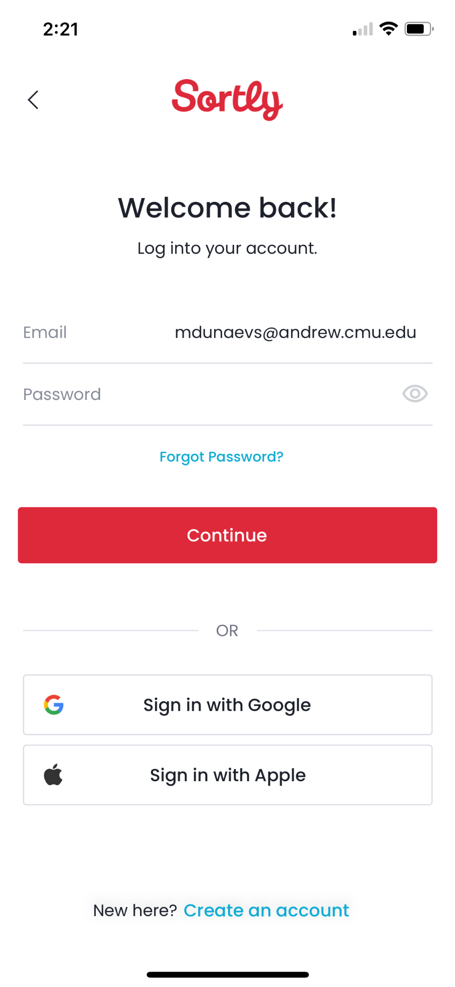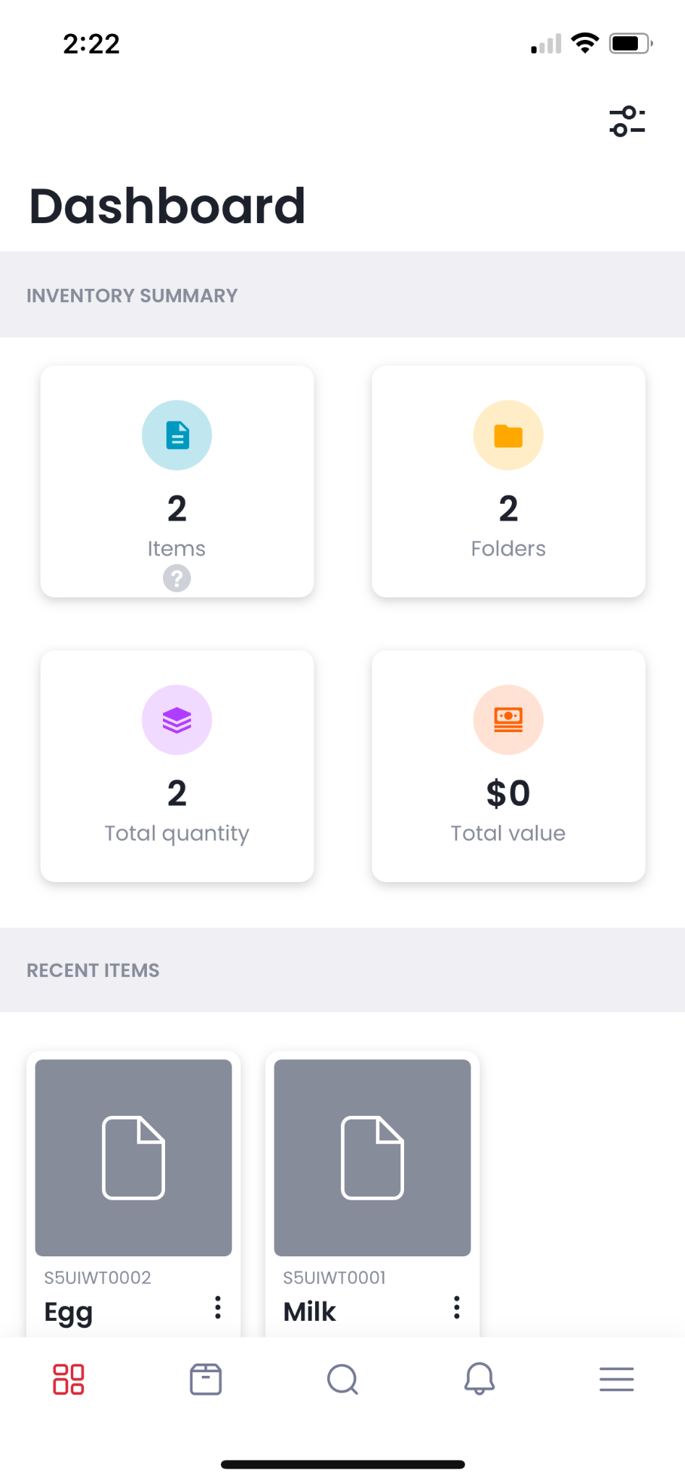

The login and dashboard screens are very similar to the desktop application.

Scanning:

Scanning can be done by clicking on the search icon on the bottom of the screen. Once on the search screen, there will be a button you can click on to open up the camera scanner.





This is the scanning screen. Make sure to place the QR code you are trying to scan within the borders of the square.

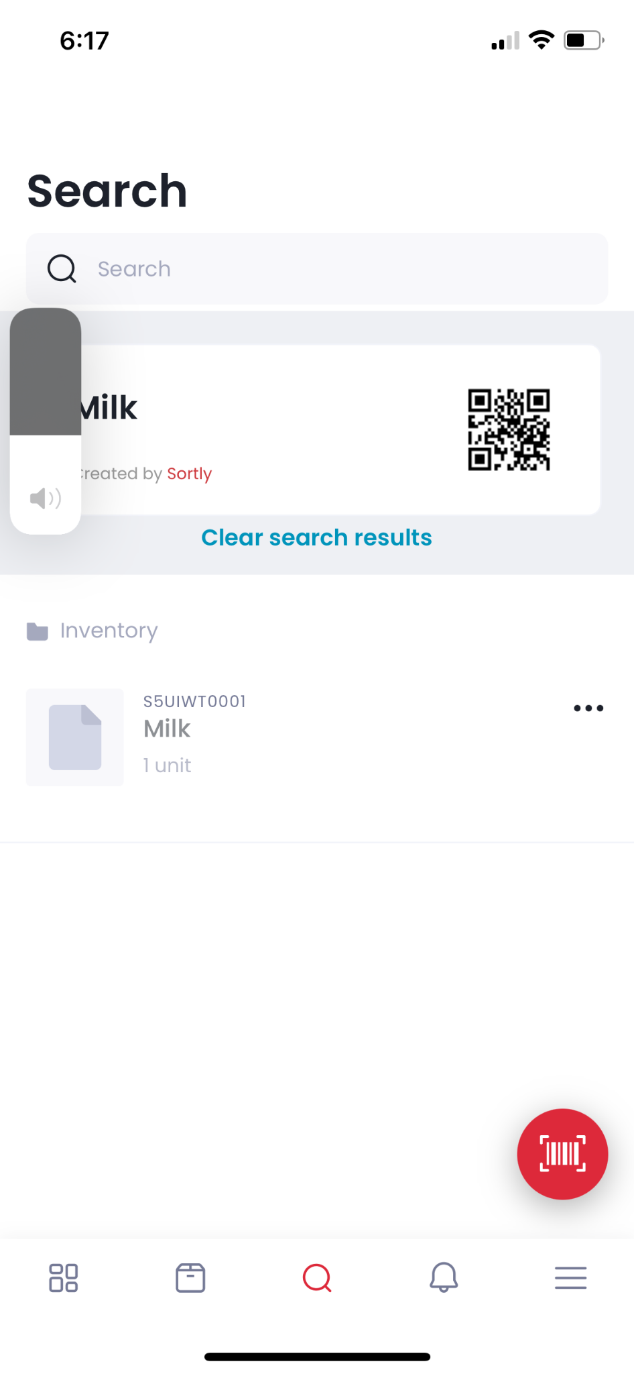

Scanning a QR code brings up a screen with all of the item information associated with that QR code. From here, you can edit item information, change inventory, move the item to another folder, etc.

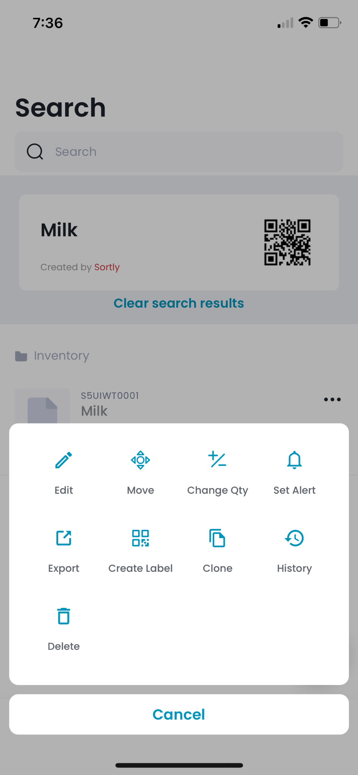

These are all the functionalities that can be accessed through the scanning system. Most likely, you would be using the change the quantity or move functions.

Creating QR Code:

When editing or creating an item, there is an option to add a bar code.



Click on the add barcode button and you will be taken to a page that asks what kind of barcode to create. You will most likely need to create a new one.

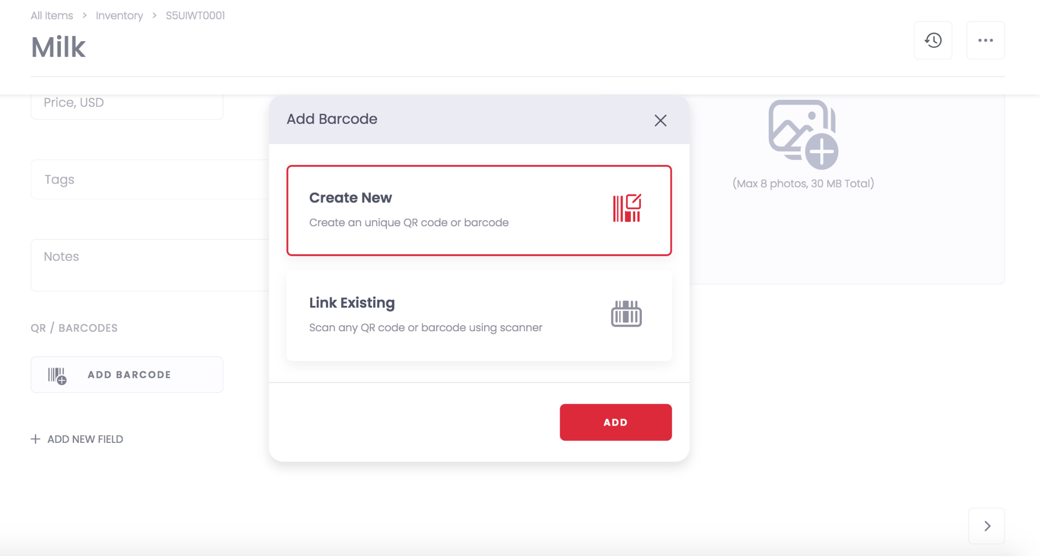

After this, you will be brought to a page with multiple options on how you want your label to look. You can choose any option based on what format/how large you want your QR code to be. You can also add a photo as a reference to which QR belongs to which image.

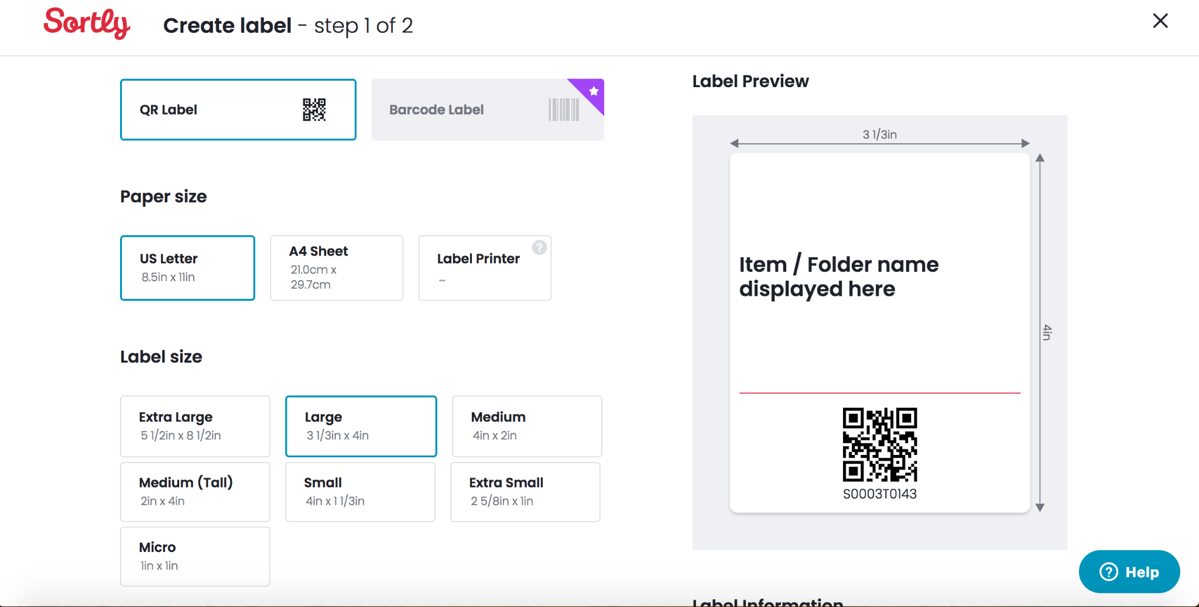

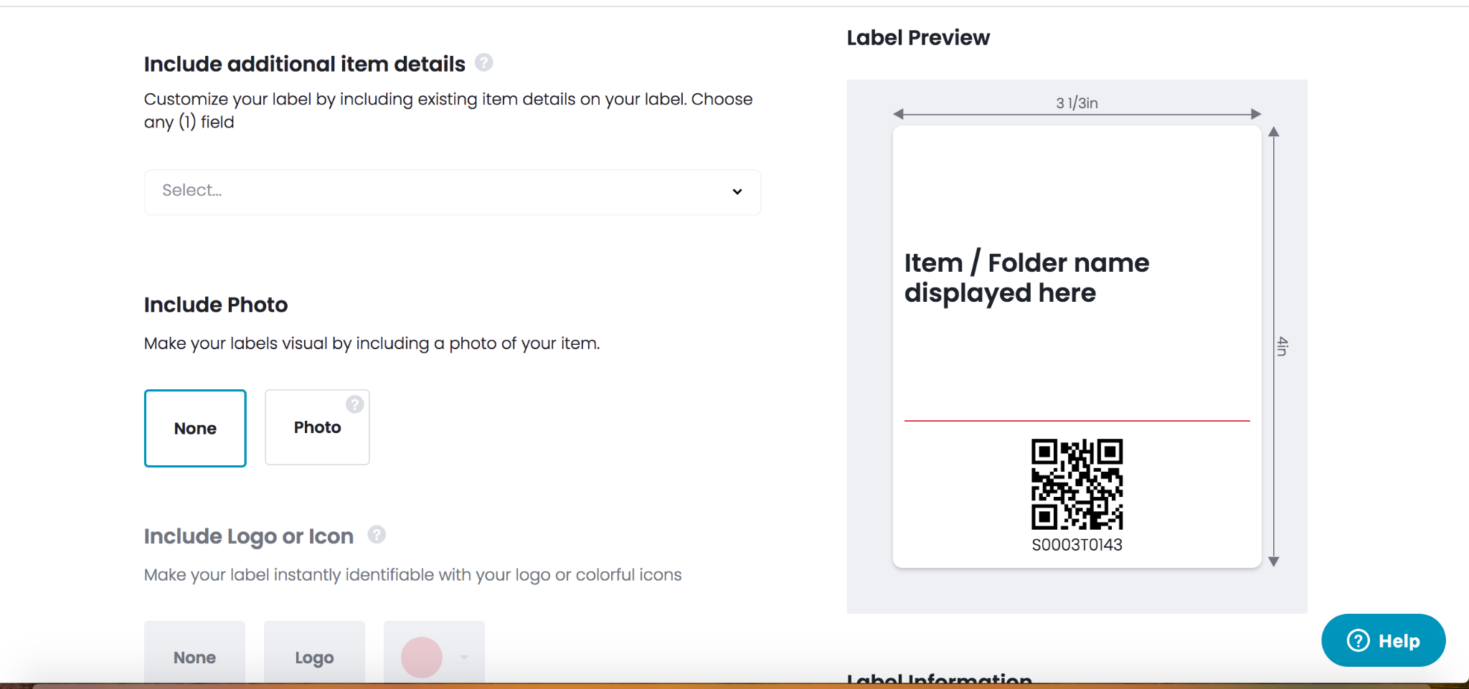

After creating your QR code, it will automatically be downloaded to your computer which you can print out. There are also options to send the code to your email address for future references.

Scanning Shortcuts:

On the mobile application, there is an option to add shortcuts to the scanning functionality.



Click on the shortcuts button.

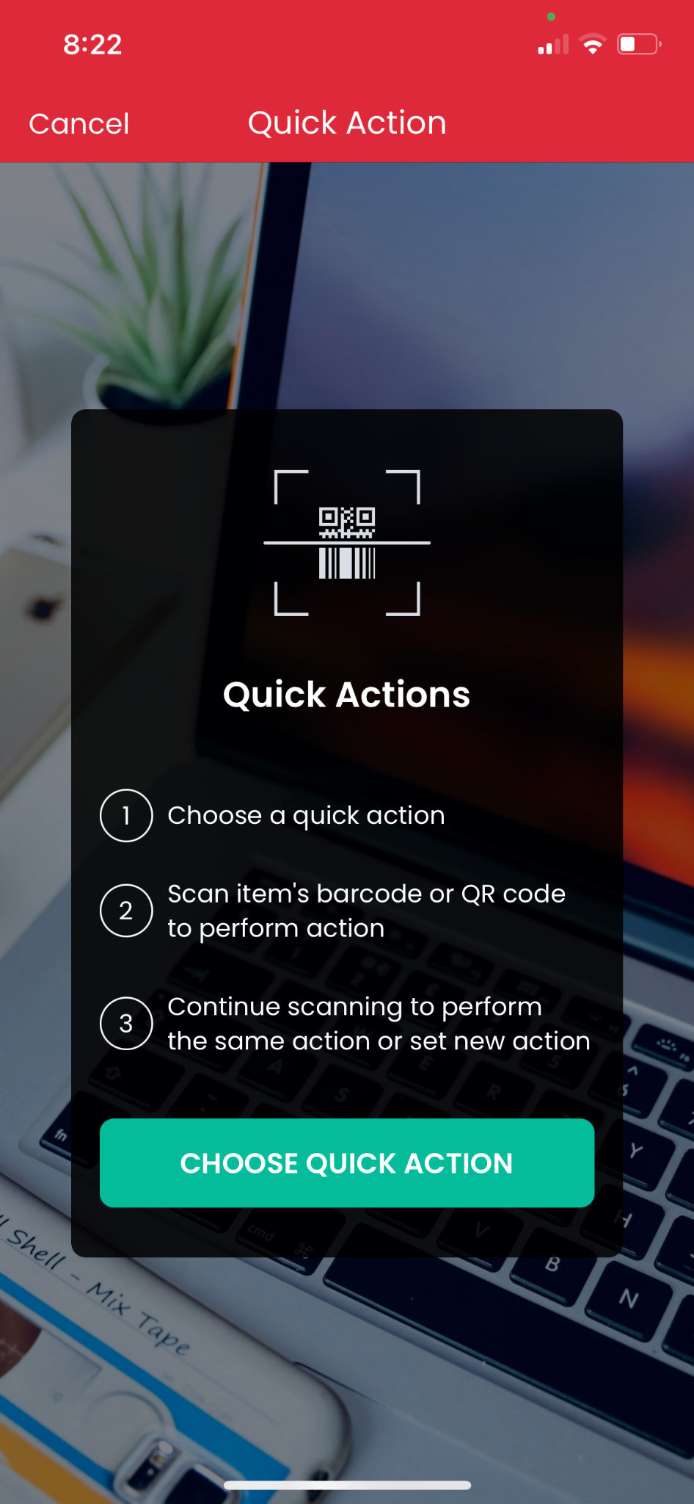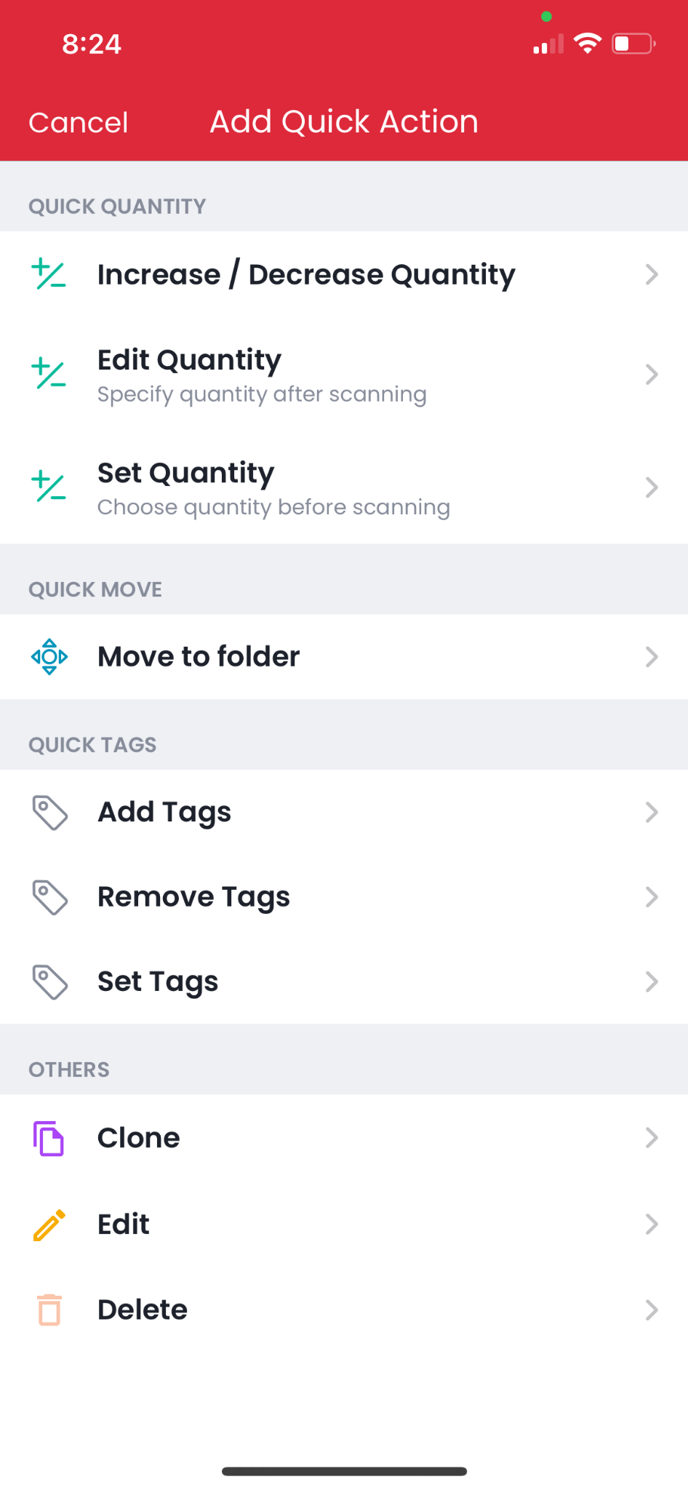

You can select whichever functions you want as a scanning shortcut. For example, we can set a quantity increase.

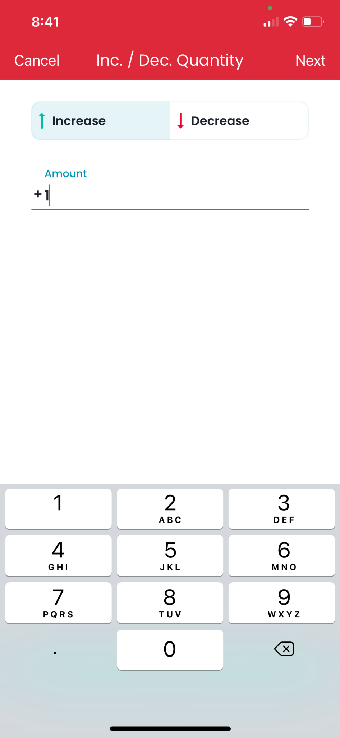

Now we can scan using this shortcut.

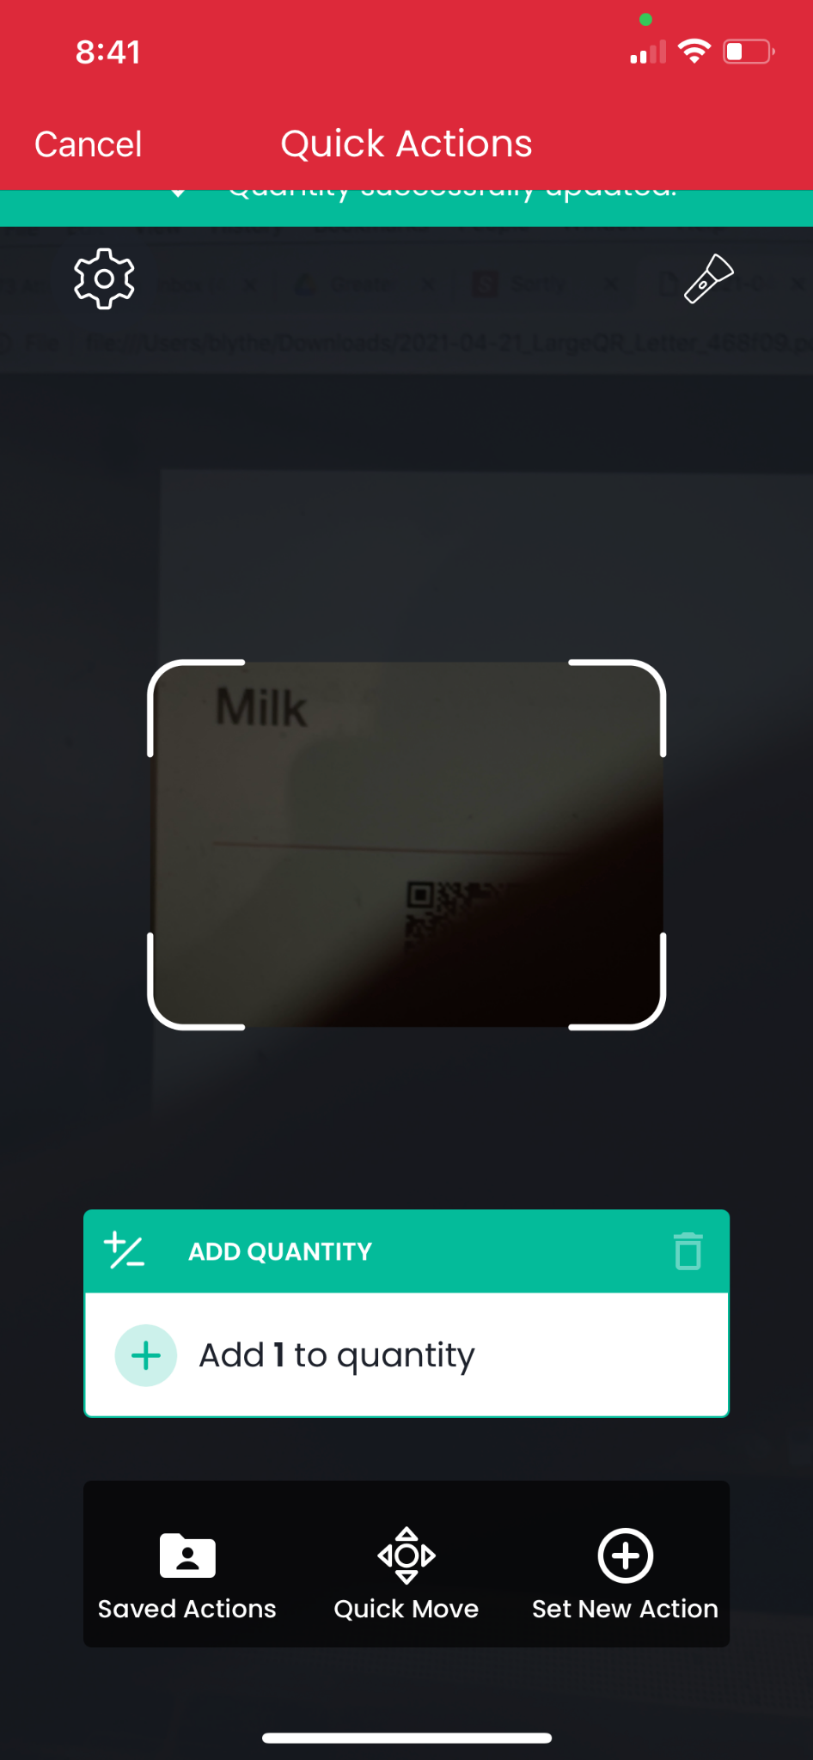

Now scanning each item will automatically add a quantity of 1 to the item inventory.

# Importing CSV Files

To import a pre-existing csv file, you want to click on the settings icon on the left side of the screen.



Once on the settings page, click on the bulk import option.



Click on the advanced import button option and upload your csv file formatted the same way as the Sortly template.

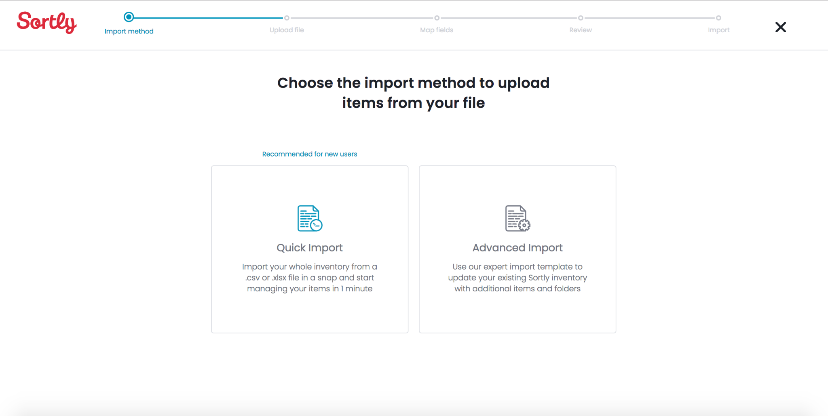

Upload your file under the “add file” line.

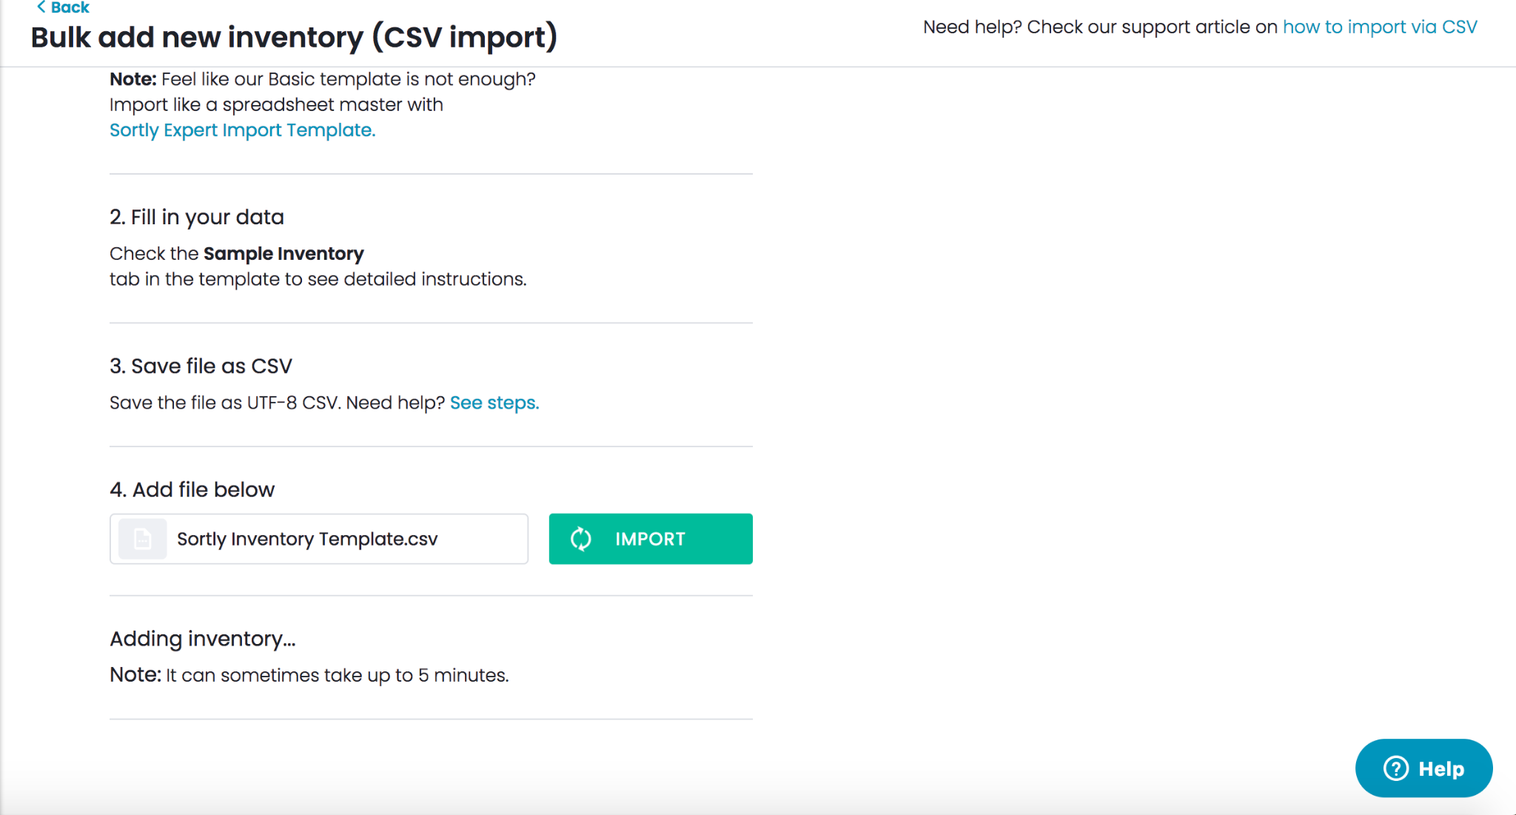

Now the contents of your csv file should be uploaded onto sortly

# Running Item Totals

In order to see the total count of an item across all folders, you must first click the gear setting icon.

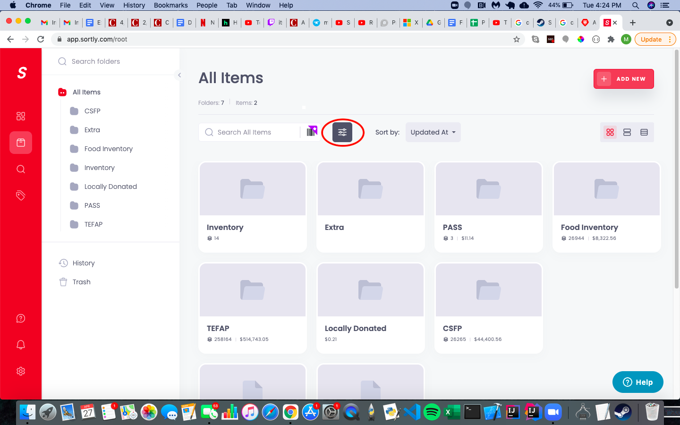

After selecting the toggle icon, turn on the “Summarize Items” option.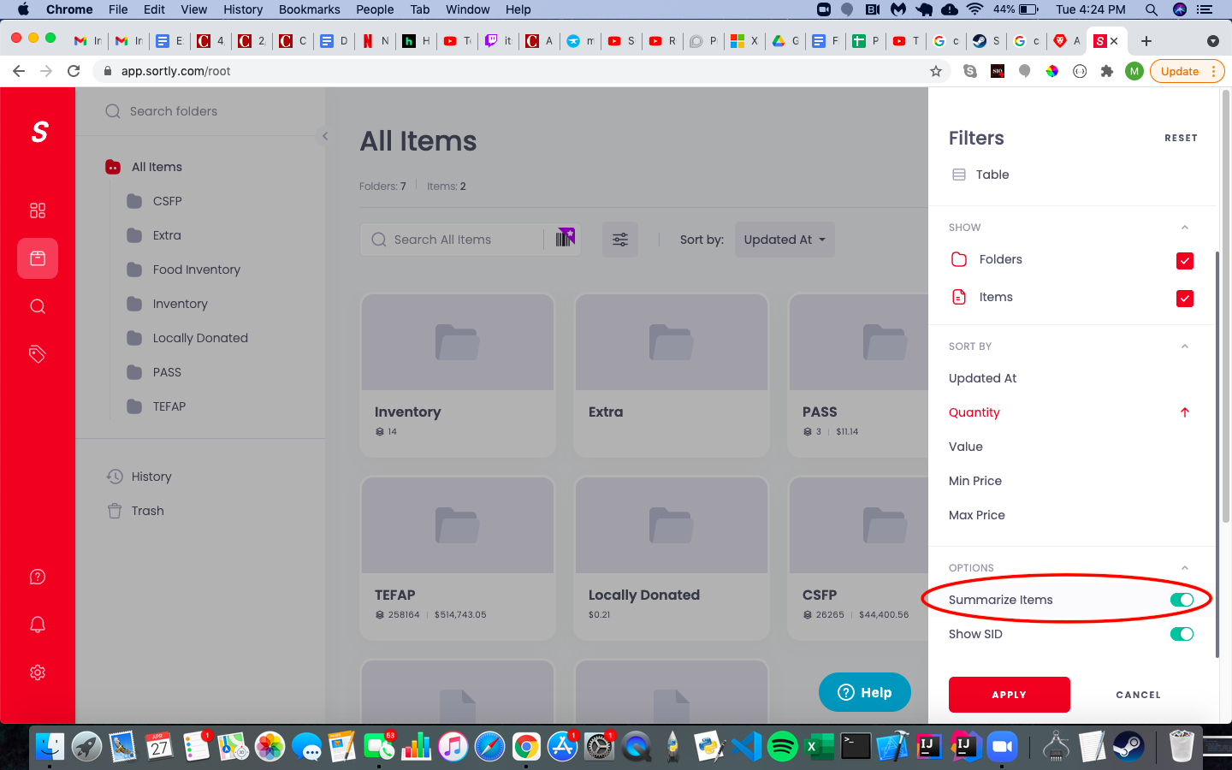

After applying this new option, you can search for the item using the search bar. For example, if we searched for the item chocolate it would show us the item total.

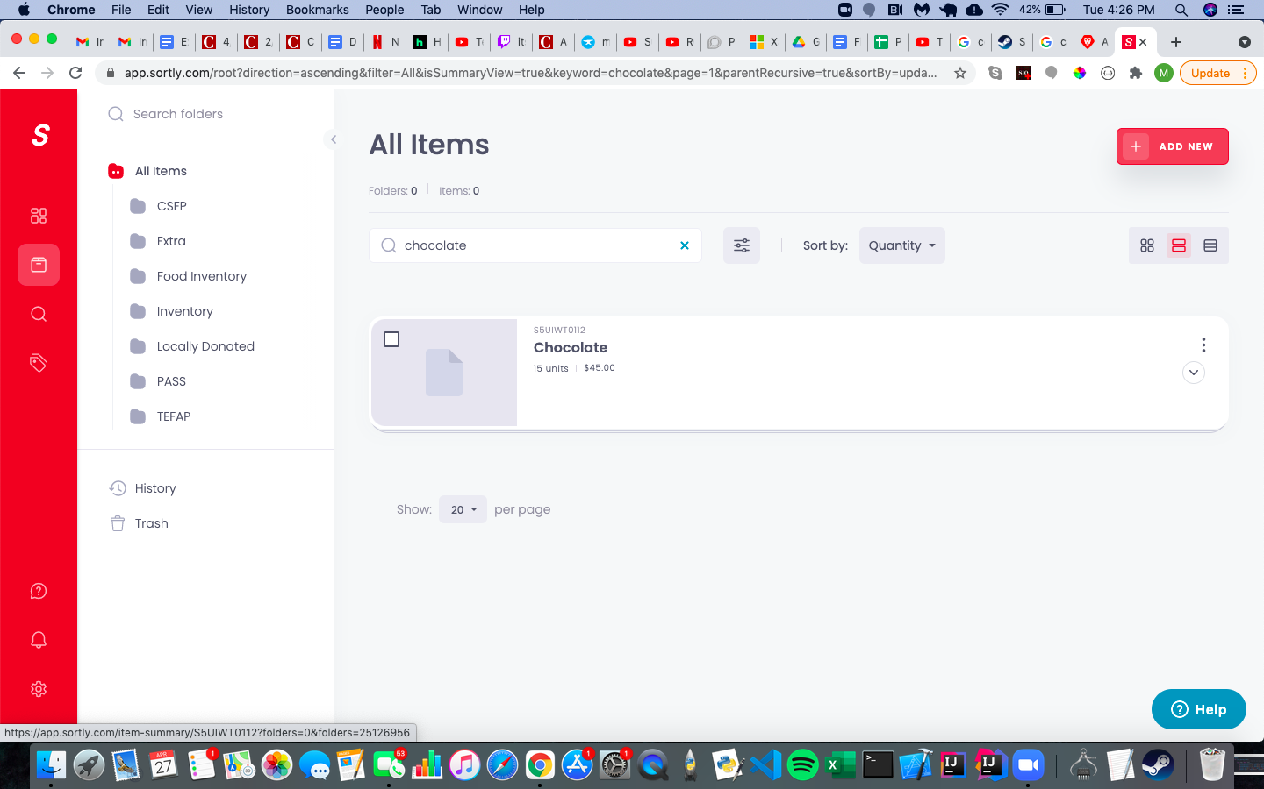

By pressing the dropdown arrow, you can see more information about the item distribution across folders.